**Chapter 1**

**Coordinate Geometry of Two Dimensions**

**1.1 Introduction**

Analytic- geometry was introduced by Rene Descartes (1596 – 1650) in his La Geometric published in 1637. Accordingly, after the name of its founder, analytic or co-ordinate geometry is often referred to as Cartesian geometry. It is essentially a method of studying geometry by mean of algebra. Its main purpose was to show how a systematic use of coordinates (real numbers) could vastly simplify geometric arguments. In it he gave a simple technique of great flexibility for the solution of a variety of problems.

**1.2 Coordinate system**

**1.2.1 Rectangular Coordinate System**

Consider a plane with two lines intersecting each other at right angles at *O* as shown in following figure. The horizontal line is called the *x*-axis and the vertical line the *y*-axis. The point of intersection of the axes is the origin. Two axes divide the plane into four quarters. Each quarter is called a ***quadrant***. The quadrants are numbered from 1 to 4 as shown, in an anti-clockwise direction.

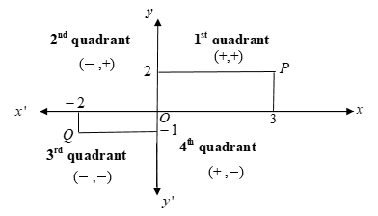

Measurements of distances on the axes are taken from *O*. On the *x*-axis measurements to the right of *O* are positive whilst those to the left are negative. On the *y*-axis measurements above *O* are positive, and those below *O* negative. The position or coordinates of a point is defined by the ordered pair x-coordinate and it’s y-coordinate. The coordinates of P defined by the ordered pair  and Q by the ordered pair .

**1.2.2 Distance between two points**

In the right-angled triangle *PQR* (Fig 1.2.2),

 (Pythagoras’ theorem).

Hence .

Thus the distance between any two points  and  is given by

.

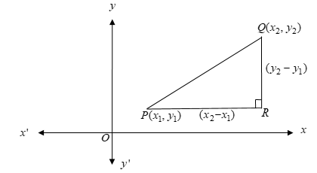

**1.2.3 Polar Coordinate System**

In [mathematics](https://en.wikipedia.org/wiki/Mathematics), the polar coordinate system is a [two-dimensional](https://en.wikipedia.org/wiki/Dimension) [coordinate system](https://en.wikipedia.org/wiki/Coordinate_system) in which each point on a plane is determined by a distance from a reference point and an angle from a reference direction. The reference point (analogous to the origin of a Cartesian system) is called the ***pole***, and the ray from the pole in the reference direction is the ***polar axis***. The distance from the pole is called the *radial coordinate* or ***radius***, and the angle is the *angular coordinate*, ***polar angle***, or *azimuth*.

## 1.2.4 Relation between polar and Cartesian coordinate system

The polar coordinates *r* and *ϕ* can be converted to the Cartesian coordinates *x* and *y* by using the trigonometric functions sine and cosine:

The Cartesian coordinates *x* and *y* can be converted to polar coordinates *r* and *ϕ* using the relations .

**Example 1:** Find the polar coordinate of (-1, -1).

**Solution:** 







*O*



So, the polar coordinate of (-1, -1) is .



**Example 2:** Find the Polar coordinate of

**Solution:**

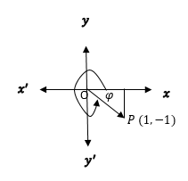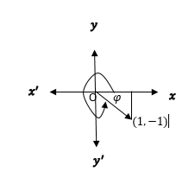

.

So, polar coordinate of is

**Exercise set 1.1**

**1.** Find the corresponding polar co-ordinates of the following points. Also locate them in  plane.

.

**2.** Find the rectangular coordinates of the following points whose polar coordinates are

given bellow. Also locate them in  plane.

.

**1.3 Straight Line**

The shortest distance between two points is a straight line.

**1.3.1 Inclination of slope of a straight line:**

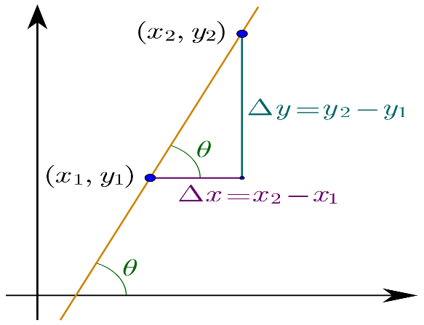

(Run)

(Rise)

The angle (), measured counter clockwise from the positive – axis to the line is called the inclination of the line or the angle of inclination of the line.

The tangent of this angle i.e. , is called the slope or gradient of the line. It is generally denoted by m. Thus m =, . The slope of the line is positive or negative according as the angle of inclination is acute or obtuse.

**Alternative Definition:**

The ratio of vertical and horizontal distances between any two points on a line is called the slope of a straight line.

**1.3.2 Different forms of straight line:**

1. **Slope Intercept form:**

Where (slope) and is the intercept.

Graph of is given below:

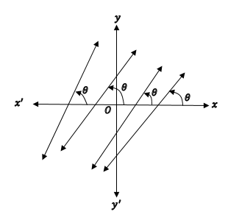 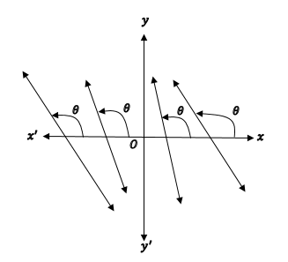

For negative slope

For positive slope

If and the line passes through origin and its equation is The graph of this equation is:

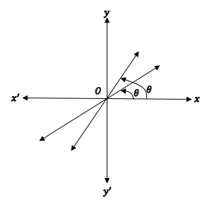 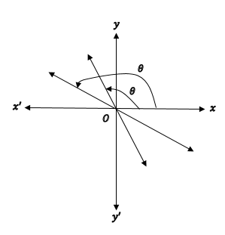

For negative slope

For positive slope

**B. Point-slope form:**

Suppose a line passing through a point and its slope is , then the equation of the line is

**C. Two point form:**

Suppose a line passing through two points and then slope of the line is

Now, using point- slope form of linear equation, two point form of straight line stands for

**D. Intercept form:**



Suppose and are and intercept of a straight line of point and then the linear equation will be

**1.3.3 Straight line parallel to an axis:**

The equation of the line parallel to -axis is

* If , then the line lies above the -axis
* If , then the line lies below the -axis
* If , then the line is the -axis itself.

The equation of the line parallel to -axis is

* If then the line lies to the right of -axis.
* If then the line lies to the left of -axis.
* If then the line is the -axis itself.

**1.3.4 Condition to be two straight lines are parallel and perpendicular:**

* Given two lines are parallel when
* If then two lines will be perpendicular.

**Exercise set 1.2**

**1.** Let and be points in the plane.

(a) Find the slope of the line that contains and

(b) Find the equation of the line that passes through and . What are the intercepts?

(c) Find the length of the segment

**2.** Find an equation of the line that passes though the point and

(a) has slope

(b) is parallel to the axis.

(c) is parallel to the axis.

(d) is parallel to the line

**3.** The relationship between the Fahrenheit (F) and Celsius (C) temperature scales is given by the linear model

(a) Sketch the graph of the equation.

(b) What is the slope of the equation and what does it represent? What is the - intercept and what does it represent?

**4.** A dry air moves upward, it expands and cools. If the ground temperature is and the temperature at a height of is , express the temperature in terms of height as a linear model.

(a) Draw the graph of the equation and what does the slope represent?

(b) What is the temperature at a height of

**1.4 Conic Sections**

Circles, ellipses, parabolas, and hyperbolas are called ***conic sections*** or ***conics*** because they can be obtained as intersections of a plane with a double-napped circular cone as shown in the following figure:



**Circle Ellipse Parabola Hyperbola**

**1.4.1 Circle**

A circle is the locus of all points equidistant from a fixed point . Fixed point is called the center of a circle and distance is called radius Considering the coordinates of locus and center Distance between and is is equal to That is

Which is the standard equation of a circle. Where .

r

**Note:**

* If the center is origin , then the equation reduces to
* Area of a circle is and length of the circumference of a circle is
* exists cause sum of two square expression cannot be negative.

**Exercise set 1.3**

**1.** Find the center and radius of

**2.** A graphic designer creates a design for a company logo. The design is a green semicircle with a white quadrant, as shown. Find the area of the green part of the design. Use 3.14 as an approximation of



**3.** The tire of a car has a radius of inches. How many revolutions does the tire need to make for the car to travel inches? Use as an approximation for .



**1.4.2 Parabola**

A **parabola** is the set of all points  that are equidistant from a fixed line and a fixed point not on the line. The fixed line is called **directrix and** fixed point is **focus.** The midpoint between the focus and the directrix is the **vertex**, and the line passing through the focus and the vertex is the **axis** of the parabola. Note that a parabola is symmetric with respect to its axis. Using the definition of a parabola, we can derive the standard form of the equation of a parabola whose directrix is parallel to the *x*-axis or to the *y*-axis.

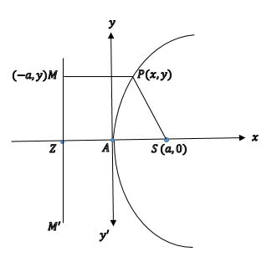

Let, the parabola has

Focus Directrix Any point on itself. Adding we get the line

According to the definition of parabola,

Which is the standard form of parabola.

* **Vertex, coordinates of focus, length of latus rectum and equation of directrix of parabola:**

|  |  |  |  |  |  |
| --- | --- | --- | --- | --- | --- |
| SI No. | Features |  |  |  |  |
| 01. | Basic shape |  |  |  |  |
| 02. | Coordinates of vertex |  |  |  |  |
| 03. | Coordinates of focus |  |  |  |  |
| 04. | Length of latus rectum |  |  |  |  |
| 05. | Equation of directrix |  |  |  |  |
| 06. | Equation of axis |  |  |  |  |
| 07. | Equation of latus rectum |  |  |  |  |

**Exercise set 1.4**

**1.** Determine the i. coordinates of vertex, ii. Coordinates of focus, iii. Equation of directrix and iv. equation of axes of each of the following parabola. Also sketch.

(a)

(b)

(c)

(d)

**1.4.3 Ellipse**

An ellipse is the locus of points in a plane whose distance from two fixed points in the plane have a constant sum.



The line through the foci of an ellipse is the ellipse’s **focal axis**. The point on the axis halfway between the foci is the **center**. The points where the focal axis and ellipse cross are the ellipse’s **vertices**.



If the foci are and and is denoted by then the coordinate of a point on the ellipse satisfy the equation

Where

Here , is the eccentricity.

* Related formulae of ellipse:

|  |  |  |  |
| --- | --- | --- | --- |
| SI No. | Features |  |  |
| 01. | Basic shape |  |  |
| 02. | Coordinates of center |  |  |
| 03. | Length of major axis |  |  |
| 04. | Length of minor axis |  |  |
| 05. | Coordinates of vertices |  |  |
| 06. | Coordinates of foci |  |  |
| 07. | Equation of latus rectum |  |  |
| 08. | Equation of directrix |  |  |
| 09. | Length of latus rectum |  |  |
| 10. | Eccentricity |  |  |
| 11. | Distance between two vertices |  |  |
| 12. | Distance between two foci |  |  |

**Exercise set 1.5**

**1.** Determine the i. eccentricity, ii. coordinates of foci, iii. coordinates of vertices, iv. Coordinates of center and v. equation of directrix of the following ellipses:

(a)

(b)

**1.4.4 Hyperbola**

A hyperbola is the locus of all points in a plane whose distances from two fixed points in the plane have a constant difference. The two fixed points are foci of the hyperbola.



If the foci are and and the constant difference is then a point lies on the hyperbola if and only if

Where , or, or,

Here, the eccentricity.

* Formulae related to hyperbola

|  |  |  |  |
| --- | --- | --- | --- |
| SI No. | Features |  |  |
| 01. | Basic shape |  |  |
| 02. | Coordinates of center |  |  |
| 03. | Equation of transverse axis |  |  |
| 04. | Equation of conjugate axis |  |  |
| 05. | Length of transverse axis |  |  |
| 06. | Length of conjugate axis |  |  |
| 07. | Coordinates of vertices |  |  |
| 08. | Coordinates of foci |  |  |
| 09. | Equation of latus rectum |  |  |
| 10. | Equation of directrix |  |  |
| 11. | Length of latus rectum |  |  |
| 12. | Eccentricity |  |  |
| 13. | Distance between two vertices |  |  |
| 14. | Distance between two foci |  |  |
| 15. | Distance between two directrix |  |  |

**Exercise set 1.6**

**1.** Determine the i. eccentricity ii. Coordinates of center iii. Equation of transverse axis iv. Equation of conjugate axis v. Coordinates of vertices vi. Coordinates of foci and vii. Equation of directrix of each of the following hyperbola and also sketch.

(a)

(b)

(c)

**1.5 Translation of coordinate axes:**

















O





Suppose that the axes, are drawn through  parallel to the original axes,  and in the same sense. Let the coordinates of P be  referred to the original axes,  referred to the new axes and the coordinates of  be  referred to the original system.

From the figure, we have

*x* = OM = OL +LM = 

*y* = PM = 

Thus the transformation equations for translation are





**Exercise set 1.6**

**1.** Determine the i. coordinates of vertex, ii. Coordinates of focus, iii. Equation of directrix and iv. equation of axes of each of the following parabola. Also sketch.

(a)

(b)

(c)

(d)

(e)

**2.** Determine the i. eccentricity, ii. coordinates of foci, iii. coordinates of vertices, iv. Coordinates of center and v. equation of directrix of the following ellipses:

(a)

(b)

(c)

(d)

**3.** Determine the i. eccentricity ii. Coordinates of center iii. Equation of transverse axis iv. Equation of conjugate axis v. Coordinates of vertices vi. Coordinates of foci and vii. Equation of directrix of each of the following hyperbola and also sketch.

(a)

(b)

**1.6 Rotational transformation**

We can consider rotational translation into two types:

i. Geometrical rotation.

ii. Axes rotation.

Here we will focus on axes rotation:

**1.6.1 Rotation of Axes**

*X*

***x***

**

*P*(*x*, *y*)

*P*(*X*, *Y*)





***Y***



***X***

***x***

*r*

*Y*

**O**

Let, be a point under coordinate system. makes an angle with positive axis.

,

.

Suppose that the coordinate system is rotated through an angle θ keeping the origin fixed. If P has coordinates  referred to the new axes, then

And

Converting equation (1) and equation (2) into matrix form we get,

**1.6.2 General Equation of Second Degree**

The general equation of second degree is

 --------------- (1)

Where *a, h, b, g, f* and *c* are constants.

**1.6.3 Angle of rotation to remove *xy* term from general equation of second degree**

The general equation of second degree is

 --------------- (1)

Under rotation through an angle , the transformation equations are





and the general equation of second degree becomes





which can be written as



where













The transformed equation will be independent of the product term  if  i.e.





.

The nature of the **conics** represent by (1)



may be predicted by the sign of the discriminant

.

Results are summarized below:

|  |  |
| --- | --- |
| **Conditions on** | **Regular Conics** |
|  | Ellipse |
|  | Hyperbola |
|  | Parabola |

**To reduce to standard form, we may follow the following steps:**

Rotate the coordinate axes through an angle θ such that to get rid of *xy* term and then use translation to reduce to standard form.

**Example:** Find the angle of rotation to remove *xy* term fromand hence write the transformed equation. Also reduce them to standard form and sketch them showing both set of axes.

**Solution:** Identifying with  and and choosing θ such that



From the triangle we see that



The values of  and  can then be computed from the half-angle formulas:













The transformation equations become



and

Substitution in the original equation gives



Collecting similar terms



or .

or.

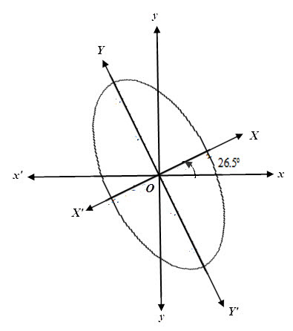

**Example:** Find the angle of rotation to remove *xy* term fromand hence write the transformed equation.Also reduce them to standard form and sketch them showing both set of axes.

**Solution:** Identifying with  and and choosing θ such that



From the triangle we see that



The values of  and  can then be computed from the half-angle formulas:









7



The transformation equations become



and

Substitution in the original equation give



Collecting similar terms



or 

or  .

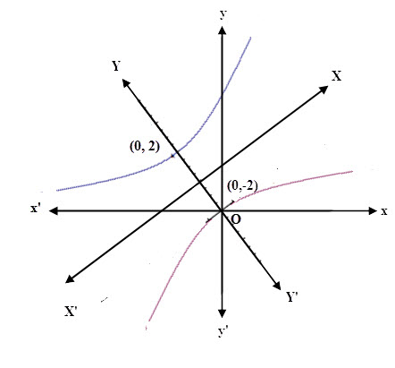

**Example:** Find the angle of rotation to remove *xy* term fromand hence write the transformed equation.Also reduce them to standard form and sketch them showing both set of axes.

**Solution:** Identifying with  and and choosing θ such that









1

From the triangle we see that



The transform equations are



and

Substitution in the original equation gives



Collecting similar terms



or 

or  .

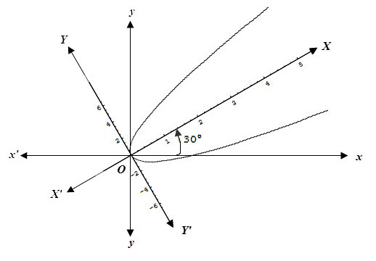

**Exercise set 1.7**

1. Find the angle of rotation to remove *xy-*term from the following curves.

(a) (b)  (c)

2. The Coordinate axes are rotated by the following given angle . Find the transformed equations of the following curves. Also reduce them to standard form and sketch them showing both set of axes.

(a) 

(b) 

(c) 

**Exercise set 1.8**

1.



A designer of a 200-feet-diameter parabolic electromagnetic antenna for tracking space probes wants to place the focus 100 feet above the vertex.

(a) Find the equation of the parabola using the axis of the parabola as the Y-axis and vertex at the origin.

(b) Determine depth of the parabolic reflector.

**2.**



A satellite dish receiver is in the shape of a parabola. A cross section of the dish shows a diameter of 13 feet at a distance of 2.5 feet from the vertex of the parabola. Write an equation for the parabola.

**3.**



The semielliptical arch in the concrete bridge in the figure3 must have a clearance of 12 feet above the water and span a distance of 40 feet. Find the equation of the ellipse after inserting a coordinate system with the center of the ellipse at the origin and the major axis on the X-axis. The Y-axis points up, and the X-axis points to the right. How much clearance above the water is there 5 feet from the bank?

**4.**



A signal light on a ship with parallel reflected light rays. Suppose the parabolic reflector is 12 inches in diameter and the light source is located at the focus, which is 1.5 inches from the vertex.

(a)Find the equation of the parabola using the axis of the parabola as the X-axis and vertex at the origin.

(b) Determine depth of the parabolic reflector.

**5.**

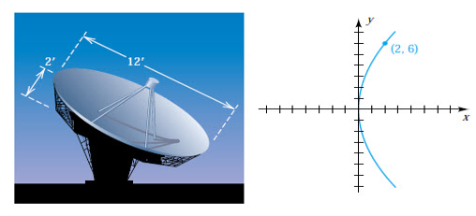

The interior of a satellite TV antenna is a dish having the shapes of a paraboloid that has a diameter 12 feet and is 2 feet deep. Find the distance from the center of the dish to the focus.